

Economics

SAC 3.1 UNIT 3 OUTCOME 3

You will have 45 minutes to complete this task plus 5 minutes reading time

Teacher: Mr. Daniel Charles

The total SAC contributes to 25/100 of SAC marks allocated for Unit 3.

Allowed materials for this task include:
- Pens, calculator, pencils, rulers, erasers, highlighters

Name ____________________________________________

Note: The grade or score for this task is only part of the internal assessment for this Unit. Your total School-assessed Coursework score may change as a result of statistical moderation by VCAA.

Grade/Score: ______ Satisfactory Completion? S/N: ______
(Provisional)

Section A – multiple choice questions

Question 1

If Australia see a decrease in their international credit rating, this would lead to

A. a decrease in the supply of the AUD and a deprecation
B. an increase in the supply of the AUD and a deprecation
C. an increase in the supply of the AUD and an appreciation
D. a decrease in the supply of the AUD and an appreciation

Question 2
If Australia’s foreign equity assets exceed its foreign equity liabilities, this means that

A. Australia has invested less overseas than foreigners have invested in Australia.
B. Australia has invested more overseas than foreigners have invested in Australia.
C. the Australian Government has increased its borrowings from overseas to fund budget deficits.
D. the Australian Government has decreased its borrowings from overseas to fund budget deficits

Question 3
An improvement in Australia’s current account balance is most likely to occur when

A. the trade balance surplus increases.
B. the terms of trade deteriorate.
C. the Australian dollar appreciates.
D. China’s economic growth slows.

Question 4
The payment of dividends to overseas shareholders will appear in the balance of payments as a

A. credit in the capital and financial account.
B. debit in the capital and financial account.
C. credit in the balance of payments on current account.
D. debit in the balance of payments on current account.

Question 5

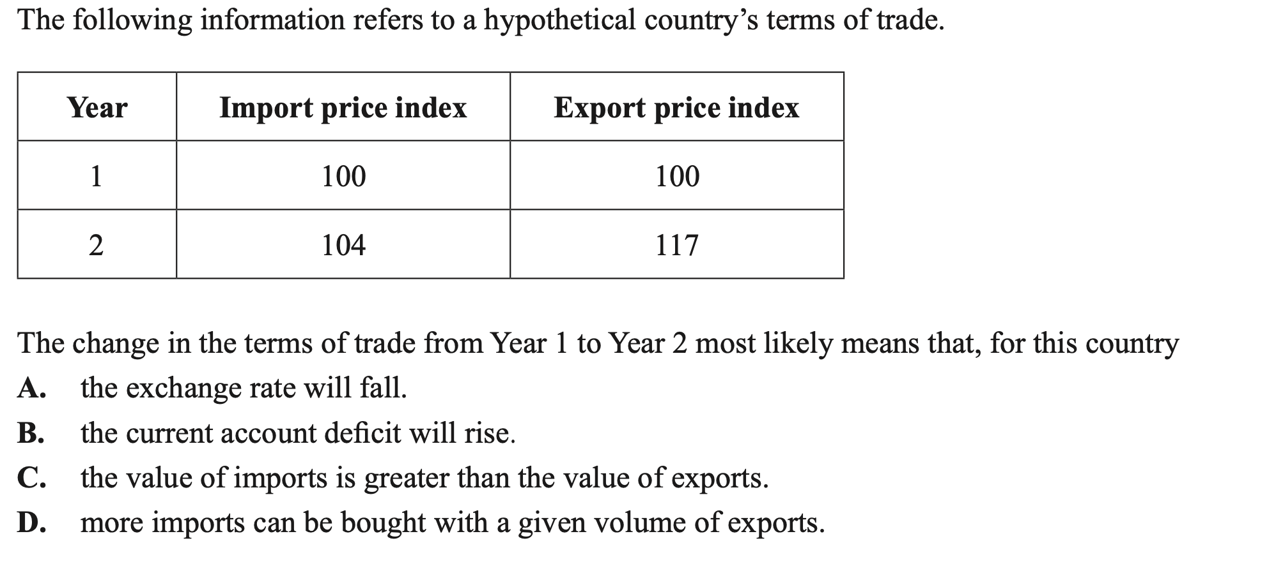

Section B – Structured questions

Question 1 (8 marks)

a. The Australian economy has had a current account surplus since 2019. Outline once factor that has led to this surplus.
2 marks
One factor that has led to the current account surplus since 2019 is a favourable movement in the terms of trade, which means the index of the average price of Australia’s exports has risen relative to the index measuring the average price of Australia’s imports. Due to Australia’s main exports such as iron ore having a low price elasticity of demand (necessities), the relatively higher average price of Australia’s exports would lead to an increase in export revenue overall. This would increase the value of credits in the balance of merchandise trade section of the current account, which contributed to the surplus.

b. Describe the influence that the current account surplus would have on the value of the exchange rate, ceteris paribus.
2 marks
The current account surplus indicates that the value of credits in the balance of goods and services, net primary income and secondary income is greater than the value of debits in these sections of the current account. This would likely mean that more foreign currency has been needed to be converted to Australian currency, leading to a net increase in the demand for the Australian currency over this time, appreciating the value of the exchange rate ($AUD) against other currencies.

c. Before 2019, the Australian economy had a current account deficit since 1975. Explain one structural cause of the persistent current account deficit.
2 marks
One structural reason for the persistent current account deficit that the Australian economy faced before 2019 was the savings and investment gap that occurs in the Australian economy. Due to Australia’s low population, there is insufficient savings in domestic banks to be available for the high level of investment that occurs in the Australian economy. Given this, it requires domestic firms to borrow from overseas financial institutions. Over time, this led to a high level of interest payments and therefore debits in the net primary income section of the current account, contributing the persistent current account deficits over many years.
d. Explain the impact that an increase in net foreign debt would have on the current account balance.
2 marks
An increase in Australia’s net foreign debt indicates that the total amount of borrowing from foreigners is greater than the lending by residents of Australia to foreigners. This mean that over time there would be an increase in the value of interest payments to foreign lenders. These interest payments will be recorded as debits in the net primary income section of the current account, having a negative impact on the current account balance (decreasing the surplus).

Question 2 (6 marks)
a. Explain the impact that the trend in the terms of trade over the last two years would have on the value of the exchange rate, and the goal of full employment.
4 marks

Exchange rate
A more favourable movement in the terms of trade means that the average price of Australian exports is increasing relative to the average price of Australia’s imports. Ceteris paribus, this will increase export revenue that Australian firms receive, meaning that more foreign currency would need to be converted to the $AUD to pay for Australian exports. This will increase the demand for the $AUD and appreciate its value.

Goal of full employment
The aforementioned favourable movement in the terms of trade and subsequent rising export revenue relative to import spending would increase the value of net exports (x-m), increasing aggregate demand in the economy. An increase in total spending in the economy would mean firms would increase national output and increase the demand for labour resources in the economy. This would decrease cyclical unemployment and therefore, ceteris paribus, have a positive impact on the goal of full employment, which is to have an absence of cyclical unemployment in the economy, and have the lowest unemployment rate possible without triggering inflation. This is called the NAIRU and is approximately 4-4.5%.

Note: you could also say that given the unemployment rate is below the NAIRU currently and inflation is high, that the favourable movement would have a negative impact on the goal.

b. Outline one possible cause for the trend in the terms of trade over the last two years.
2 marks
One possible cause for the favourable movement in the terms of trade over the last two years in higher commodity prices cause by an increase in global demand for Australia’s main exports, such as iron ore. An increase in the global demand for commodities like iron ore and coal would increase the global price of these commodities, for which Australian firms have no influence and are ‘price takers’. Given this, the index measuring the average price of Australia’s exports rose relative to the index measuring the average price of imports, indicating a favourable movement in the terms of trade.

Question 3 (7 marks)
a. Explain how the following factors might influence the value of the exchange rate, ceteris paribus:
3 marks

Currency speculation
If overseas investors believe that the value of the Australian exchange rate will appreciate, they will look to purchase Australian currency so that when it appreciates, they will be able to sell it for a profit. This will increase the demand for the Australian dollar ($AUD) and appreciate its value.

Note: or you could explain it the other way around- that if they believe the currency will depreciate they will sell it, increasing the supply of the AUD and depreciate it.

A change in relative interest rates
C change in interest rates in Australia will change the relative return investors get on interest earning assets, and therefore change the value of the currency. For example, currently Australia has a lower cash rate than the USA’s official interest rate. This means investors would get a higher return on interest earning assets in the USA, and they would look to invest there instead of Australia. This will increase the supply of the Australian dollar ($AUD) and depreciate its value.

An increase in import spending
A rise in import spending means that Australian residents are purchasing more foreign-made goods and services. This will require an increase in the amount of Australian currency that needs to be converted to foreign currency in order to purchase these imports, increasing the supply of the $AUD and depreciating its value.

b. The current inflation rate in Australia is 7%, well above the goal of low inflation. Analyse how a movement in the exchange rate would reduce inflationary pressures in the Australian economy.
4 marks
The goal of low inflation is for consumer price inflation to increase by 2-3%, on average, over time. Given that the current inflation rate is 7% and well above this goal, an appreciation of the exchange rate would reduce inflationary pressures. Firstly, the appreciation would increase the price that foreign consumers pay for Australian exports, decreasing the demand for exports. This would also decrease the price that Australian consumers pay for imports, increasing the demand for imports. This will decrease the value of exports and increase the value of import spending, reducing the overall value of net exports (X-M) and decrease aggregate demand (AD). Lower AD in the economy will mean firm cut production levels, and move the economy further away from productive capacity, putting downward pressure on demand inflation.

In addition, the aforementioned decrease in the price of goods imported to Australia due to the appreciation would see the costs of production fall for firms that import factors of production (raw materials, capital) and intermediate goods. Lower costs of production will allow firms to offer lower prices to consumers, leading to a decrease in cost inflationary pressures in the economy.
Question 4 (4 marks)
a. Identify and explain two factors that you improve Australia’s international competitiveness and describe how this would impact the current account balance.
4 marks
One factor that would increase Australia’s international competitiveness would be productivity growth. An increase in labour productivity growth, for example, would mean greater output per unit of input (labour output per hour), reducing the per-unit cost of producing goods and services. This would allow exporting firms to reduce prices for their goods and services, increasing international competitiveness.

A second factor that would increase international competitiveness would be the exchange rate. If the value of the $AUD depreciates against another currency, this will mean that the price of Australia’s exports will decrease for foreign consumers, making their exports more internationally competitive.

The increase in international competitiveness would increase the demand for Australia’s exports, increasing the value of credits in the balance of goods and services (BOGS) in the current account, increasing the current account surplus.

